Supply
Date: April 30, 2025

I. PURPOSE.
This meeting establishes a recurring battle rhythm of the DoD Supply Working Group to deliver processes and quality data standards that exemplify Accuracy, Conformity, Consistency, and Integrity to our Logistics Supply Community.

II. ATTENDEES.
Component | Primary | Alternate
ODASD(LOG) | ☒Dawn Izzi
DEDSO | ☒Dr. Gail Fuller ☒Steve Nace | ☒William “Rip” Rippey ☒Claudia Snowden
DAAS | ☐Pablo Gomez | ☐Gary Woodall
Army | ☒Oliver Pryor | ☐Tiffanie Dew
Marine Corps | ☐Kevin Austin | ☐Major Irsik
Navy | ☒Shannon Winters | ☒Gerald O’Sullivan
Air Force | ☒William “Wes” Wenzel | ☐Danielle Woods-Lewis
SOCOM | ☐Luke Boutot | ☐CW5 Sanders
TRANSCOM | ☐Dan Eisenberg | ☐James Decarli
DLA | ☐Brian Anderson | ☐John McDonald
DSCA | ☐Michelle Davis
GSA | ☐Shanna Smith | ☒George Oakes
FAA | ☒Dr. Sarah Owens | ☐Hannah McClellan

III. Action Items.
Date Opened | Action | Assigned To | Date Due | Date Closed | Status
2/19/2025 | List of known Summit agenda topics | - DEDSO | TDB |  | Open
3/26/2025 | DEDSO Supply to discuss possible changes to the PDC Response Template for non-concurrence to an entire change purpose. Being internally staffed in DEDSO. Suspense 4/22/2025. | - DEDSO | 4/16/2025 | 4/30/2025 | Closed

IV. PDC/ADC Pipeline.
PDC/ADC # | Meeting Added | Title | Status
PDC 1460A | 1/8/2025 | Addendum to ADC 1460 Pre-Position Release Orders Process | ADC sent to ODASD(L) on 4/23/25
PDC 1472 | 6/5/2024 | Procedures for Correcting/Adjusting Ownership Changes After Goods Receipt | Distributed for formal coordination on 4/24/25. Suspense date is 5/28/25.
ADC 1256 (Withdrawal) | 2/19/25 | Approved Defense Logistics Management Standards (DLMS) Change (ADC) 1256, Automatic Return of Unserviceable Reparable Parts Replaced During Maintenance and Associated Credit Processing (MILSTRIP/Supply/Finance) | Submitted to DEDSO Deputy for ADC review on 3/19/25
PDC 1478 | 8/21/2024 | Clarified Price Adjustments via DLMS Status Update | Finishing up Long-term Procedures. Need to meet with DLA Distribution.
ADC 1483 | 9/11/2024 | 867I Materiel Issue of Expended Ordnance | On hold due to new X12 data maintenance changes
PDC 1492 | 1/8/2025 | Mandatory Use of Shipment Status and Returns | Signed on 02/03/25. Placed on hold by the originator (DLA) pending receipt of all required data. Comments are still being collected during the hold process.
PDC 1497 | 3/5/2025 | Notification of Hazardous Waste Delivery Order and Shipping Status | In development
PDC 1491 | 3/26/2025 | Government Furnished Property (GFP) Embed | In development
PDC 1415A | 3/26/2025 | 1415A, New Defense Logistics Management Standards 536R Transaction to Support Required Acquisition and Valuation Data Elements | Submitted to ODASD(L) on 4/25/25
PDC 1501 | 4/16/2025 | Key Supporting Document Inclusions for Government Furnished Property Audit Compliance (Supply) | Submitted to DEDSO Deputy on 4/28/25

V. Agenda Items.
- Save-the-Date: DLMS Virtual Summit – TBD

- Trading Partner ADC Implementation Review

- DEDSO Supply provided an update on the ADC baseline project that they have been working on over the last few months. The purpose of the project is to determine what supply related Approved DLMS Changes (ADCs) have been implemented by all trading partners, if necessary, or if trading partners do not plan on implementing the change. Due to the lack of visibility, DEDSO explained that they will require the support of the Supply Process Review Committee (SPRC) to determine which ADCs have and have not been implemented by all trading partners and their enterprise business systems.

- The Army expressed concerns about the number of changes that would require manual review and recommended that anything older than 20 years be marked as implemented or withdrawal the change and not include it in the population that the trading partners will need to review. Multiple trading partners concurred with Army’s position, and ODASD(L) requested clarification on how ADCs would be withdrawn without conducting any kind of review. Navy, however, expressed that they would not feel comfortable with withdrawing any ADCs without conducting a thorough review of each ADC, to which DEDSO confirmed to the working group that a blanket implemented, or withdrawal determination cannot be done without a thorough review.

- PDC 1500 Converted Back to PDC 1415A

- DEDSO provided an explanation on why PDC 1500 was being converted back to the original PDC 1415A format which will replace ADC 1415 in its entirety. The main reason for the change in formatting was because DEDSO felt that format would be easier for the Portfolio Managers that are charged with systemic implementation of DLMS changes.

- Non-Concurrence to Entire PDCs

- Working group members were informed that there is no plan to change the DLMS comment matrix at this time due to the intent to transition to the DocuSign formal coordination format. If a trading partner knows that they will be non-concurring to the entire purpose of a change request, they should inform DEDSO prior to formal coordination if possible or before submitting a formal response. This will allow DEDSO to set up any necessary meetings to determine if a compromise is possible. If all else fails, just submit a simple non-concurrence without citing any specific portion marking until the new DocuSign platform is ready to be implemented.

- Potential Changes to Business Rule Routing Logic for Government Furnished Property Related Inventory

- ODASD(A), DEDSO and DAAS are reviewing the potential impact of changing the transactional routing logic of specific DLMS transactions related to Government Furnished Property. The change would route the transactions based on information located in the Functional Group Header of the transaction versus the normal routing which uses information located in the N1 segments of the Transaction Set Header and Transaction Set Detail segments. More information to follow pending the conclusion of research being conducted by.
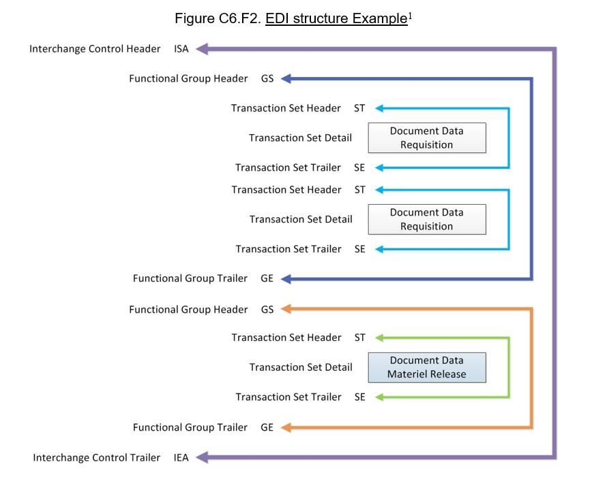

VI. ACTIVITIES AND NEWLETTER.

DEDSO monthly updates and activities for the DLMS Community can be found via the following link: https://www.dla.mil/Defense-Data-Standards/About-Us/

VII. ADDITIONAL DEDSO Supply GENERAL COMMUNICATION.
Do you have a question, hot topic, or an update related to Supply; we encourage you to send us an email at DEDSO.Supply@dla.mil.

